

**Test 2 Banked Curves, Torque, Equilibrium & Centre of Mass  
PHYSICS 3AB TASK 3B**

**Kingsway Christian College**

**March 27, 2015**

Instructions:   
Answer **ALL** questions.  
You may use your formula book and scientific calculator.  
Give all numerical answers correct to 3 significant figures.  
You are required to show **ALL** working in order to be given appropriate marks.   
A correct answer with no working could receive only ${\frac{1}{5}}^{th}$ of the marks allotted.   
It is a good idea to draw free body diagrams for questions involving forces.

It is also good to use clear, neat diagrams when appropriate.

**Marks________/85 = _______%**

**Section A: Short answer questions 35 out of 85 marks.**

1. 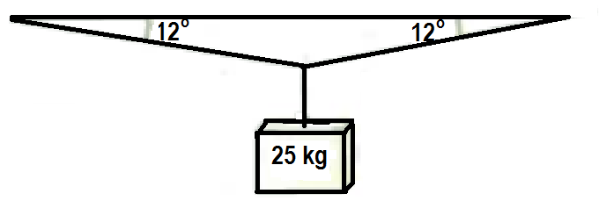When a mass of 25 kg is hung from the middle of a fixed straight aluminium wire, the wire sags to make an angle of 12o with the horizontal. Determine the tension in the wire. [3]
2. 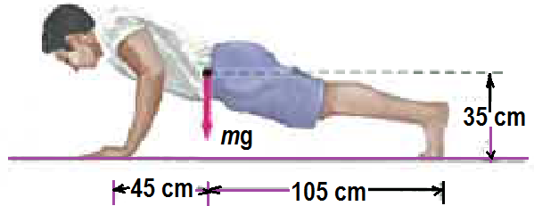A man doing push-ups pauses in the position shown. His mass $m=75 kg$. Determine the normal force exerted by the floor  
     
   1. On each hand [2]
   2. On each foot [2]
3. 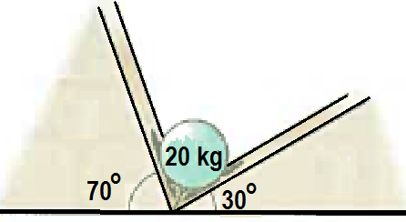A 20 kg sphere rests between two smooth planes as shown. Determine the magnitude of the force acting on the sphere exerted by each plane. [4]
4. 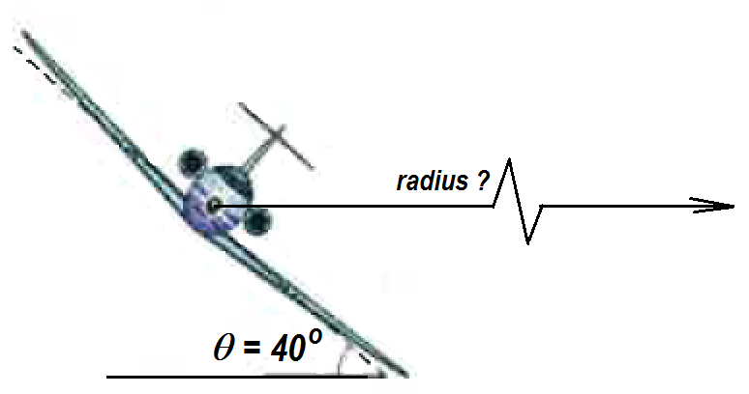An airplane is flying in a horizontal circle at a speed of 480 km.h−1.
   1. Is it possible for the airplane to fly in a horizontal circle without banking? Explain briefly. [2]

* 1. Draw the forces acting on the airplane as it flies banked in the horizontal circle. [2]
  2. Calculate the radius of the horizontal circular fly pathway. [4]

1. 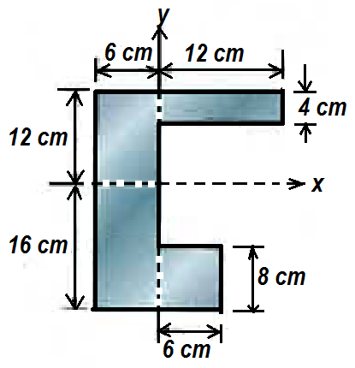Calculate the ***x*** and **y** coordinates of the centre of mass of the shape given below. [4]

1. Determine the position of the centre of mass of the system of three particles ${ m}_{1}=3 kg, m_{2}=4 kg, and m_{3}=8 kg$**.** If $m_{3}$ is gradually increased does the centre of mass of the system move closer to ${ m}_{3}$**,** away from ${ m}_{3}$ or remain stationary? Briefly explain with appropriate equations. [3]

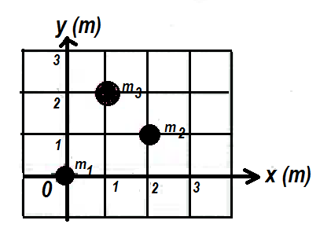

1. 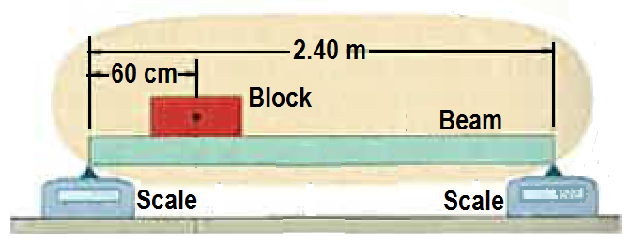A uniform beam, of length 2.40 m and mass 12.8 kg is at rest on two scales. A uniform block, with mass 24.6 kg is at rest on the beam, with its centre a distance 60.0 cm from the beam’s left end. What do the scales read? [3]
2. The figure shows a mobile of toy penguins hanging from a ceiling. Each crossbar is horizontal, has negligible mass, and extends three times as far to the right of the wire supporting it as to the left. Penguin 1 has mass 4.80 kg. What are the masses of penguins 2, 3 and 4? [4]

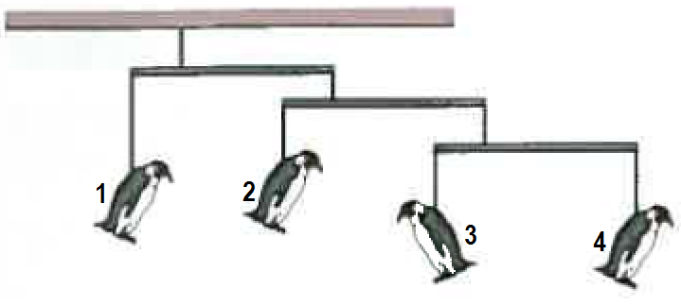

1. 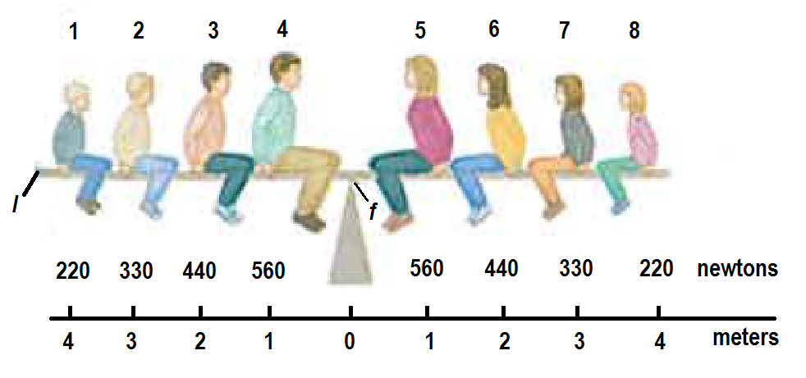 A Physics Brady Bunch, whose weights in Newtons are indicated is balanced on a seesaw.  
   1. What is the number of the person who causes the largest torque about the rotation axis at *fulcrum f*
      1. Clockwise [1]
      2. Anticlockwise [1]
   2. What is the value of the maximum
      1. Clockwise torque about *f*? [1]
      2. Anticlockwise torque about *f*? [1]
   3. Write the number of the person and calculate the maximum moment of the person about left end *l.* [2]

**SECTION B Calculations.** Answer all questions. **50 out of 85 marks**

1. 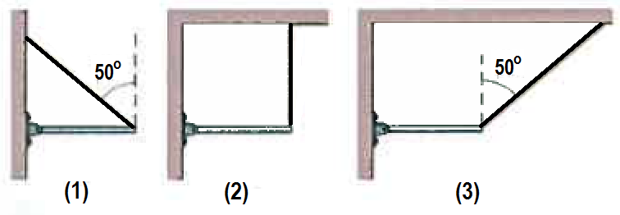The figure shows three situations in which the same horizontal rod is supported by a hinge on a wall at one end and a cord at its other end. Rank with some explanation, the situations (greatest first) according to the magnitude of   
   1. The force on the rod from the cord, [2]
   2. The vertical force on the rod from the cord, [2]
   3. The vertical force on the rod from the hinge [2]
   4. The horizontal force on the rod from the hinge [2]
2. 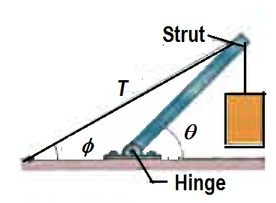A concrete block of mass 225 kg hangs from the end of the uniform strut of mass 45.0 kg. For the angles ***φ*** = ***30.0o*** and ***θ*** = ***45.0o*** find  
   1. The tension **T** in the cable [2]
   2. The horizontal and vertical components of the force on the strut from the hinge.  
       [2]
   3. The resultant force on the strut from the hinge. [2]
3. A climber with a weight of 533.8 N is held by a rope connected to her climbing harness. The force of the rope on her has a line of action through her centre of mass. The indicated angles are ***θ = 40.0o*** and ***φ = 30.0o***. Her feet are on the verge of sliding on the vertical wall.
   1. Draw the free body diagram of the climber. [3]
   2. What is the tension force of the rope?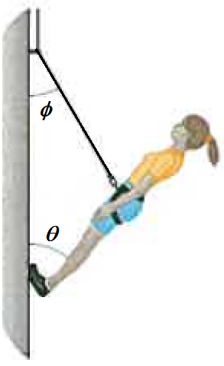 [3]
   3. What is the resultant force from the wall on her climbing shoes? [3]
4. 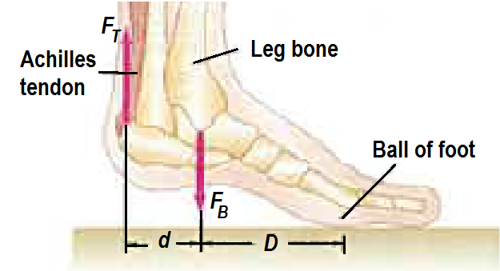 The Achilles tendon is attached to the rear of the foot as shown. When a person elevates himself just barely off the floor on the “ball of one foot,” estimate the tension ${ F}_{T }$ in the Achilles tendon (pulling upward), and the (downward) force ${ F}_{B }$ exerted by the lower leg bone on the foot. Assume the person has a mass of 72 kg and $D$ is twice as long as $d$**.**  [3]
5. 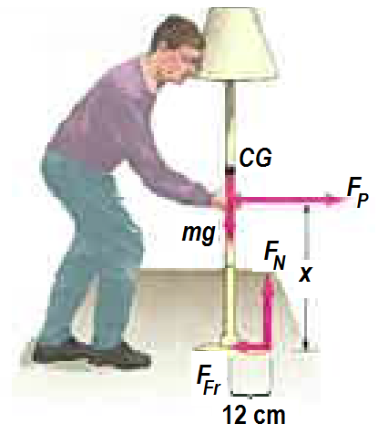 A person wants to push a lamp (mass 7.2 kg) across the floor, for which the friction force is ${\frac{1}{5}}^{th}$ of the normal reaction force. Calculate the maximum height $x$ above the floor at which the person can push the lamp so that it slides rather than tips over. [3]
6. A banked circular highway curve is designed for traffic moving at 60 km.h−1. The radius of the curve is 200 m?

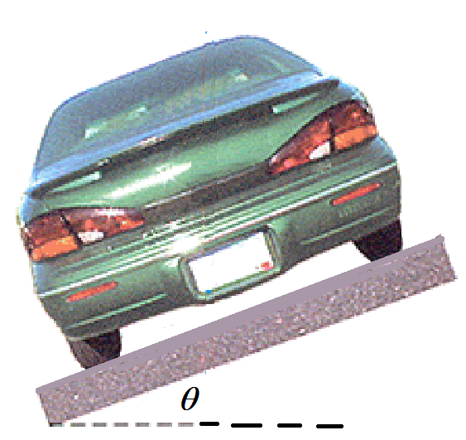

200 m radius

* 1. Calculate the bank angle $.$ [2]
  2. The 1600 kg car is travelling at 40 km.h−1 on this rainy day.
     1. Draw the forces acting on the car for this situation. [3]
     2. Write the equations of motion for the vertical and horizontal forces. [2]
  3. The car speeds up to 80 km.h−1. Calculate the sideways frictional force and normal reaction force on the car for this situation. [4]

1. Consider a ladder with a painter climbing up it. If the mass of the ladder is 15.0 kg, the mass of the painter is 65.0 kg and the ladder begins to slip at its base when her feet are 70% of the way up the length of the ladder. Assume a smooth wall. Calculate  
   1. 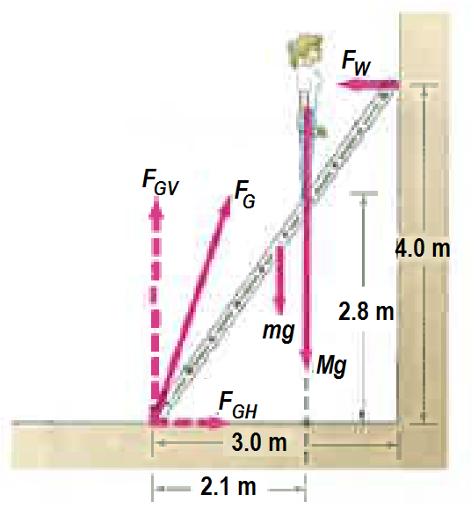The wall reaction force [3]
   2. The ground reaction force. [4]
   3. Describe some practical solutions on how to make the ladder more stable, based on your Physics knowledge of stability and equilibrium. [3]

**END OF TASK 3b (Test 1b)**